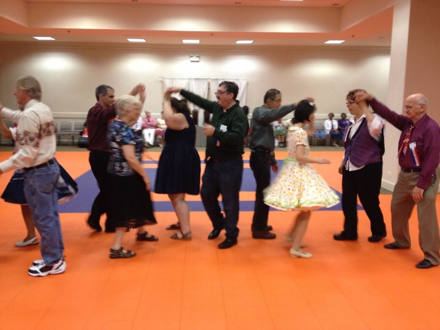

**Try it!**

**Try it!**

**JOIN NOW!**

**JOIN NOW!**

Fun

Fun

Friendship

Friendship

**Laugh**

**Laugh**

Today’s

Music

Today’s

Music



**Thursday Aug 27, 2015**

**7:00 p.m. – 9:30 p.m.**

***Insert Your Location***

***Address***

***City State and Zip Code Refreshments Served***

Move your body. Move your brain.

Sample a uniquely American dance hobby that can change your life. You’ll be Square Dancing before you can say ‘dosido.’

* No experience necessary.

* No partner required.

* All ages welcome.

* No special outfit needed.

* NO CHARGE!

***More info: Frankie Terry-773-568-0916***

***Judith Hayes-773-667-2676***

[Insert email and website](mailto:rdrnnr08@comcast.net)