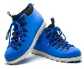
Would you spend two hours each week doing something good for your health?

An enjoyable activity that involves using your body and your brain?

A multi-dimensional approach to healthy living is modern square dancing and incorporates the three holistic dimensions
Physical, Mental and Social.

If you can walk, you can square dance!
It’s for everyone!
No partner required!
No special clothes!

Modern Square dancing not only lifts the spirits, but also provides healthy cardiovascular exercise and mental stimulation that can add quality to your life.
It is definitely a wise choice of activity.
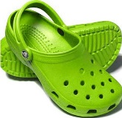

Where else can you walk to music, laugh a lot, and meet great people – all at the same time.

DANCE:
- Have Fun
- Laugh More
- Make Friends
- Exercise More
- Reduce Stress
- Improve memory skills

Learn more about this great activity from a club in your community.

Peterborough: 704 743 3077
www.otonabeesquares.org
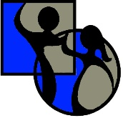
otonabeesquares@gmail.com
Cobourg:
Lindsay: 705 324 9559

For more info:
Ontario Square Dance Federation
www.squaredance.on.org
Toll Free 1-866-206-6696

